Ewindfly mission is to promote CAD / CAM / CAE globally and provide Conceptual CAD training and services for the clients, engineers, and students. Businesses are welcome to negotiate with Afsaneh about their needs in Applied Mechanical Design. For negotiation please use JivoChat dialogue box, located at the bottom right corner of Home Page of: www.ewindfly.net | Ewindfly  64 Calley Drive, Leeming, WA, Australia, 6149 | To: The Head of Mechanical Engineering Discipline  Chat with us, we are online! JivoChat  Please find above Phrase at the bottom right corner of Home Page of: www.ewindfly.net then we can chat and talk. | Ewindfly  Mechanical CAD  Engineering Services  Research/Innovation  Project Management  Training & Assessment  Engineering Tutoring  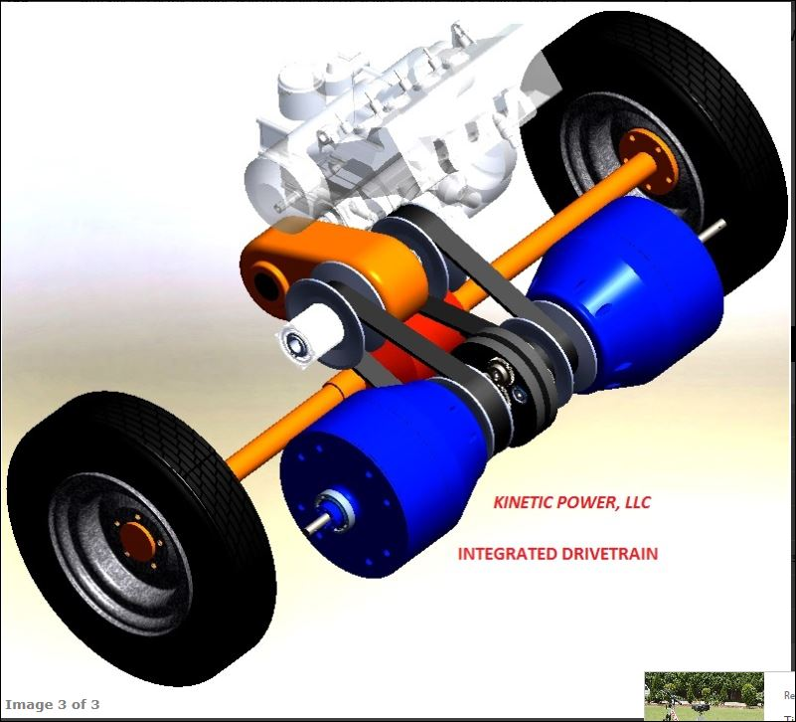

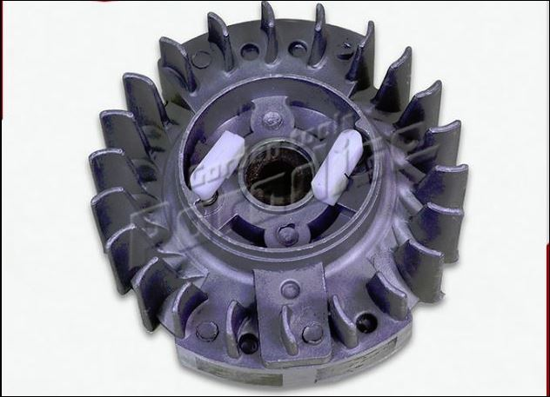  Perseverance, and severe interest of Afsaneh in her work, her discipline in jobs and continued persistence in entrusted duties are from outstanding attributes that puts Afsaneh among successful trainees in the Machine Design Team. We Wish her Success.  (Dr Rahim Pourabdolrahim, Head of the Machine Design Department and Afsaneh’s Supervisor in Standard Gear Boxes CAD Software Development) | Mrs Cooper completed everything asked of her, was willing, courteous and punctual.  (Pauline Hansen, Human Resources Manager, Apache Energy Limited, Oil Company, Perth, 1998)  Afsaneh is one of our competent designers who has been proved to be capable of undertaking major projects in Computer Aided Design, and Hydraulics.  (Dr M. Tebyani, Dr Engineer in Electrical Engineering, President of I.R.O.S.T., Iranian Research Organization for Science and Technology, 1984) | Key Offerings  - English Grammar Proofing  - Web Casting  - Project Management Practice  - Research & Innovation  - CAD: SolidWorks, TurboCAD, AutoCAD  training, assessment, tutoring and  drafting  - Load Analysis  - Simulation [Sim Wise 4D]  - Computational Mechanics [Algorithm]  - Turbo-machineries  - Renewable Energy: Flywheel Energy  Storage System, Wind Turbine,  River Turbine, All Electric Car,  Floating Clinic, Air Ambulance  - Gear Boxes  - eLearning / eAssessment  - Educational Technology  - Technical Writing  - Training and Assessment  Contact Us  64 Calley Drive, Leeming, WA, Australia, 6149  MOB: +61 437 635 038  flycadeng@live.com.au  www.ewindfly.net

